

**Year 12 Human Biology**

**Unit 3: Science Inquiry – Biotechnology & Evidence for Evolution (5%)**

**Task 10** Validation: **/55**

**TYPE:** Science Inquiry

**CONTENT:** Biotechnology and Evidence for Evolution

**TIME:** 60 minutes

**Evidence for Evolution & Biotechnology Validation**

Genome sequencing involves determining the complete DNA sequence of an organism’s nuclear and mitochondrial DNA. For this investigation, 5 of each species’ mitochondrial genomes were sequenced.

This can be used to determine the relationship between Humans and Rhesus macaques, Pygmy chimpanzees, Gorillas, Japanese monkeys and Bush babies, by comparing their mitochondrial genome size.

**Question 1 (4 marks)**

1. Describe the aim of this investigation. (1 mark)

|  |  |
| --- | --- |
| **Description** | **Marks** |
| To determine the relationship between humans and Rhesus macaques, Pygmy chimpanzees, Gorillas, Japanese monkeys and Bush babies, by comparing their mitochondrial genome size. | 1 |

Straight from above, must have all.

1. Name the specific dependent variable for this investigation (1 mark)

|  |  |
| --- | --- |
| **Name** | **Marks** |
| Genome size (/base pairs/other suitable unit) | 1 |

1. Write a suitable hypothesis for this investigation. (2 marks)

|  |  |
| --- | --- |
| **Description** | **Marks** |
| Humans will have a similar/the same genome size to pygmy chimpanzees/gorillas (any species named above) | 1 |
| as opposed to the other primates/rhesus macaques/Japanese monkeys/bush babies (any species named above) | 1 |

OR: If the genome size between the species being compared are similar, they are more closely related to each other/more recent common ancestor (1), than if their genome sizes are more different, indicating a more distant relation/common ancestor (1)

**Question 2 (11 marks)**

The results from this investigation are below. Use Figure 1 to answer parts a) to d) below.

**Figure 1: Mitochondrial genome size of humans compared to primates**

|  |  |  |
| --- | --- | --- |
| Scientific name | Common name | Genome size (base pairs) |
| *Homo sapiens* | Human | 16,500 |
| *Macaca mulatta* | Rhesus monkey | 17,092 |
| *Pan paniscus* | Pygmy chimpanzee | 16,500 |
| *Gorilla beringei* | Gorilla | 16,405 |
| *Macaca fuscata* | Japanese monkey | 17,000 |
| *Galagidae* | Bush baby | 16,500 |

Sources of genome data: Brown et al. (1979); Ferris et al. (1981); George (1982); Hayasaka et al (1986); Harihara et al. (1986).

1. Draw a phylogenetic tree to represent these results. (2 marks)

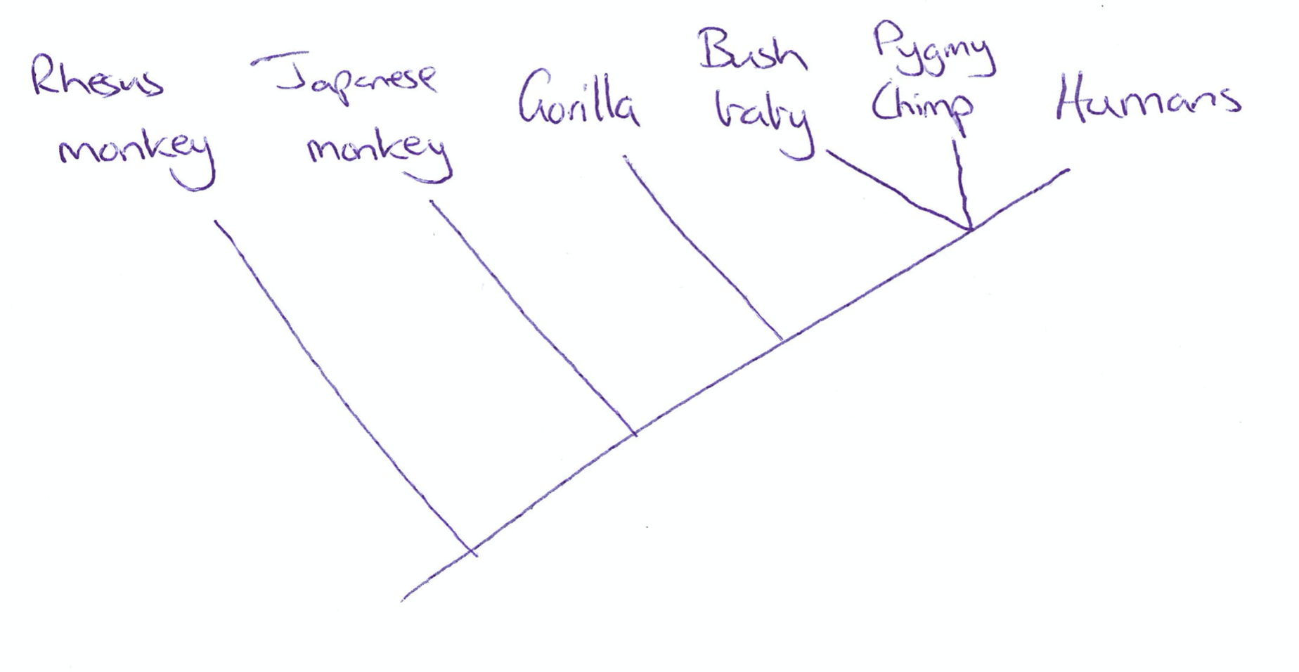

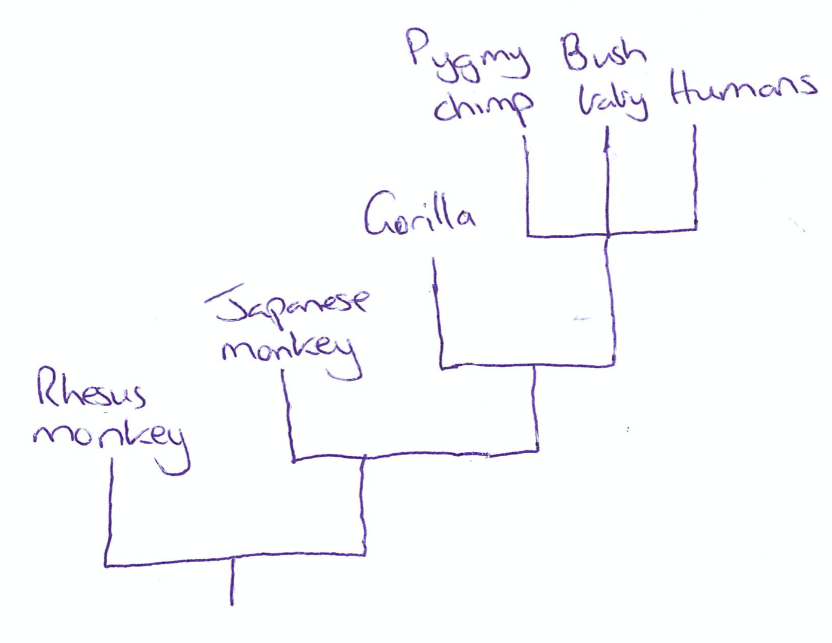

|  |  |
| --- | --- |
| **Diagram** | **Marks** |
| Correct order of first three specimens ie. Rhesus monkey most distant common ancestor to humans, Japanese monkey, Gorilla | 1 |
| Humans, pygmy chimpanzee and bush baby all come from the same common ancestor | 1 |

1. Write a suitable conclusion for this investigation. (2 marks)

|  |  |
| --- | --- |
| **Description** | **Marks** |
| Hypothesis not supported (assuming all students just chose one species) | 1 |
| Refer to results to support response.  e.g. Humans had the same genome size as both the Pygmy chimpanzee and the Bush baby at 16,500 base pairs | 1 |

1. Based on the information provided, is this investigation valid and reliable? Justify your response and describe how this investigation could be improved. (3 marks)

|  |  |
| --- | --- |
| **Justify + Improvements** | **Mark** |
| Reliability   * This experiment was not reliable. * The number of trials/number of specimens whose genome was sequences was 5/too few. * Increase sample size: 30+ for each group | 1-3 |

Did not accept “may have been reliable” it is a yes or no and justify.

Comparative studies of anatomy also provide evidence for evolutionary change over time.

1. Name and describe one (1) aspect of comparative anatomy, include how this would support the data from Figure 1 above.

(4 marks)

|  |  |
| --- | --- |
| **Name** | **Marks** |
| Homologous structures/vestigial organs/ Embryology | 1 |
| **Describe feature** |  |
| Homologous structures: species with a similar structure and (may have) a different function. | Any 1 |
| Vestigial organs: structures once of importance in other species but have reduced in size to reduce energy consumption. |
| Embryology: comparing the embryos shows similarities between different species at different stages. |
| These similarities indicate a common ancestor. | 1 |
| **Describe how feature supports the data above** |  |
| Humans and the primates mentioned (can list primates names/say all species here) have the same forelimb structure (pentadactyl limb) | Any 1 |
| Humans (chimps and gorillas) have the coccyx which is the remnants of a tail which is present in other primates (monkeys mentioned) |
| Humans and the primates mentioned as embryos have no paired appendages/the presence of a well-developed tail/embryonic gill slits and arches. |

**Question 3 (5 marks)**

Biotechnological techniques such as PCR and gel electrophoresis allow for the rapid analysis of multiple samples of DNA.

1. Describe the function of each of the following in gel electrophoresis of DNA.
2. Agarose gel: (1 mark)

|  |  |
| --- | --- |
| **Description** | **Marks** |
| Pores/spaces between molecules of agarose allow the molecules of DNA to travel through it (sorting the pieces by size) | 1 |

1. Electric current: (1 mark)

|  |  |
| --- | --- |
| **Description** | **Marks** |
| Causes the negatively charged DNA to move towards the positive pole/electrode  (Must have both) | 1 |

1. Outline would happen to the DNA fragments if you forgot to turn the current off. (1 mark)

|  |  |
| --- | --- |
| **Description** | **Marks** |
| The DNA fragments would run off the end of the gel | 1 |

1. Describe how different sized DNA fragments are separated by the gel matrix. (2 marks)

|  |  |
| --- | --- |
| **Description** | **Marks** |
| Longer DNA pieces take longer to get through the gel due to more resistance | 1 |
| Shorter fragments travel faster due to less resistance  (must compare long to short) | 1 |

Recombinant DNA involves combining sources of DNA from two different sources and is used in genetic engineering.

Parts (d) – (g) of this question refers to the diagram below which outlines how synthetic insulin is produced.

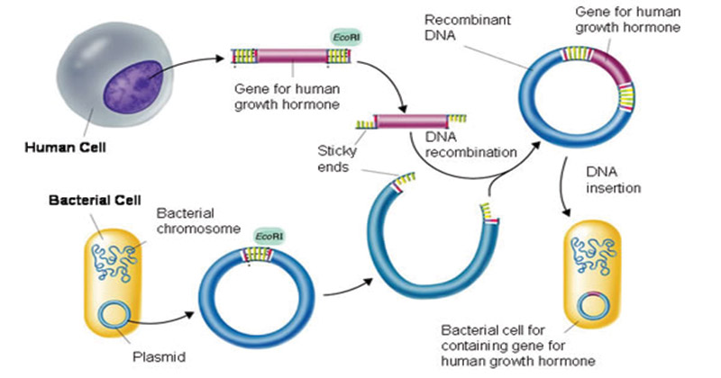

**D**





**C**

**B**

**A**

1. Name structure A in the diagram above. (1 mark)

|  |  |
| --- | --- |
| **Name** | **Marks** |
| Plasmid/Vector | 1 |

Not transgenic organism as it has not yet been altered.

1. Describe what occurs at B in this scenario. (2 marks)

|  |  |
| --- | --- |
| **Describe** | **Marks** |
| Restriction enzymes | 1 |
| Isolate the insulin gene/cut the plasmid at required section | 1 |

1. Describe what occurs to enable C to be produced. (2 marks)

|  |  |
| --- | --- |
| **Describe** | **Marks** |
| DNA ligase | 1 |
| Splices/joins the plasmid with the insulin gene (to produce recombinant DNA) | 1 |

1. State the function of structure D. (1 mark)

|  |  |
| --- | --- |
| **State** | **Marks** |
| D (bacterium cell) is incubated to produce millions of copies/replicates via binary fission | Any 1 |
| D contains the insulin gene and so has the ability to produce insulin |
| Insulin can then be extracted and purified |

**Question 4 (5 marks)**

Examine the diagram of a gel below and answer the following questions.

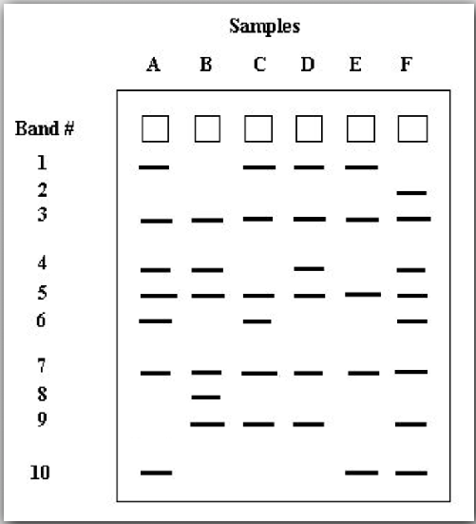

1. Outline what the bands in the drawing of the agarose gel represent. (1 mark)

|  |  |
| --- | --- |
| **Description** | **Marks** |
| DNA fragments (which are approximately the same size/length of base pairs)  OR Short tandem repeats  OR DNA profile/fingerprint | 1 |

1. Name band(s) travelled slowest. (1 mark)

|  |  |
| --- | --- |
| **Description** | **Marks** |
| Band number 1 | 1 |

1. On the above drawing, label the positive and negative ends of the gel. (1 mark)

|  |  |
| --- | --- |
| **Description** | **Marks** |
| Negative pole closest to the wells and the positive pole further from the wells | 1 |

1. Determine how many bands are shared in common by all of the individuals? List the common bands.

(1 mark)

|  |  |
| --- | --- |
| **Description** | **Marks** |
| (3 bands) Bands 3, 5 and 7 | 1 |

1. Determine if there any bands which are unique to only one individual? If so, which one/s? (1 mark)

|  |  |
| --- | --- |
| **Description** | **Marks** |
| Band 2 (Sample F) and Band 8 (sample B) | 1 |

**Question 5 (5 marks)**

Orangutans are an endangered species of ape that live in Southeast Asia. Their numbers have dwindled due to habitat loss and poaching, but there are currently efforts to save the orangutans.

DNA fingerprinting has been used by Dr. Benoit Goossens at Cardiff University to better understand mating and genetic variation in orangutans.

Mother baby Male 1 Male 2

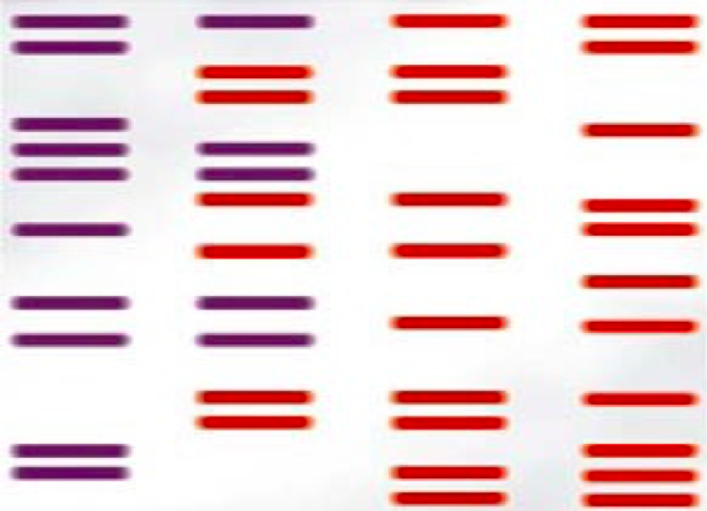

1. Use the diagram above to determine who the father is of the baby orangutan. (1 mark)

|  |  |
| --- | --- |
| **Description** | **Marks** |
| Male 1 | 1 |

1. Explain how you reached this conclusion using evidence from the DNA fingerprint. (2 marks)

|  |  |
| --- | --- |
| **Description** | **Marks** |
| Identify which bands of the baby were from the mother | Any 2 |
| Remainder of baby’s bands were from male 1 |
| Compare the bands of the baby, mother and two males |

1. Explain what is meant by DNA profiling/fingerprinting, and how it is different to DNA sequencing. (2 marks)

|  |  |
| --- | --- |
| **Description** | **Marks** |
| DNA profiling: process of using gel electrophoresis to identify the pattern of DNA | Any 1 |
| DNA profiling: process of analysing STR’s using gel electrophoresis |
| DNA sequencing: establishing the exact base (nucleotide) sequence of DNA for the sample | 1 |

**Question 6 (19 marks)**

1. Describe the purpose of PCR? What role does electrophoresis play in this process? (2 marks)

|  |  |
| --- | --- |
| **Description** | **Marks** |
| Produces large quantities/amplifies/copies DNA samples/particular region of DNA | 1 |
| Gel electrophoresis: separates the DNA fragments out for comparison/confirms a successful PCR | 1 |

1. Describe the structure and function of a primer. (3 marks)

|  |  |
| --- | --- |
| **Description** | **Marks** |
| Short strand of DNA complementary to the target DNA/gene | 1 |
| Identifies the start of the gene/DNA strand/binds to the starting region to be amplified | 1 |
| Enables Taq/DNA polymerase to attached/extend/elongate | 1 |

1. Describe what Taq polymerase is and outline its function. (2 marks)

|  |  |
| --- | --- |
| **Description** | **Marks** |
| Enzyme which adds nucleotides to the primer | 1 |
| and builds a complementary strand of DNA | 1 |

1. List the three stages in PCR and describe what occurs at each stage. (6 marks)

|  |  |
| --- | --- |
| **Description** | **Marks** |
| 1. Denaturing | 1 |
| ~90-95 degrees causes the DNA strand to separate into single strands | 1 |
| 1. Annealing/hybridisation | 1 |
| ~60 degrees allows primers to bind to the DNA strands | 1 |
| 1. Elongation/Extension | 1 |
| 72 degrees allows Taq polymerase to add nucleotides (builds new DNA strand) | 1 |

1. Explain why a water sample placed in the thermocycler or PCR machine alongside the DNA sample. (2 marks)

|  |  |
| --- | --- |
| **Description** | **Marks** |
| To act as a control | 1 |
| To check for cross contamination | 1 |

1. Name any four of the reagents in the Master Mix or PCR mix. (2 marks)

|  |  |
| --- | --- |
| **Description** | **Marks** |
| Buffer,  Mg Cl2 (Cofactor)  dNTP mix/nucleotides  forward primer  reverse primer  Taq polymerase  Water  Template DNA | ½ per correct answer |

1. Describe the structure and function of a DNA ladder. (2 marks)

|  |  |
| --- | --- |
| **Description** | **Marks** |
| DNA fragments of a known length/size (in base pairs) | 1 |
| Enables you to estimate the size of DNA product | 1 |